Library APIs

Definition
# Source: AI Source: Provided by: [Data Path: Persons Table -> ID Column: 1, Name_En Column: Motasem Essam] -> From: [ChatGPT] on [1/19/2026]
A Library API is a set of pre-written code and functions that programmers can use to make their software development faster and easier. It’s called a “library” because it’s like a collection of reusable tools.

Simple Definition
# Source: AI Source: Provided by: [Data Path: Persons Table -> ID Column: 1, Name_En Column: Motasem Essam] -> From: [ChatGPT] on [1/19/2026]
Library API = ready-to-use code that helps developers perform tasks without writing everything from scratch.

How Library APIs Work
# Source: AI Source: Provided by: [Data Path: Persons Table -> ID Column: 1, Name_En Column: Motasem Essam] -> From: [ChatGPT] on [1/19/2026]
- A programmer includes the library in their project.
- They call functions or methods provided by the library.
- The library does the work behind the scenes.

Examples
# Source: AI Source: Provided by: [Data Path: Persons Table -> ID Column: 1, Name_En Column: Motasem Essam] -> From: [ChatGPT] on [1/19/2026]
- Math library – functions for advanced math operations
  - Example: sqrt(), sin(), cos()
- Graphics library – functions to draw images or animations
- Networking library – functions to send requests over the internet
- Database library – functions to connect, read, and write data in databases

Difference Between Library API and Web API
# Source: AI Source: Provided by: [Data Path: Persons Table -> ID Column: 1, Name_En Column: Motasem Essam] -> From: [ChatGPT] on [1/19/2026]
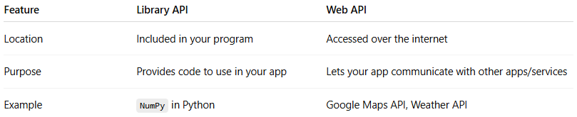
Feature | Library API | Web API
Location | Included in your program | Accessed over the internet
Purpose | Provides code to use in your app | Lets your app communicate with other apps/services
Example | NumPy in Python | Google Maps API, Weather API

Why Library APIs Are Useful
# Source: AI Source: Provided by: [Data Path: Persons Table -> ID Column: 1, Name_En Column: Motasem Essam] -> From: [ChatGPT] on [1/19/2026]
- Save time – no need to write complex functions from scratch
- Ensure reliability – tested code reduces bugs
- Focus on your main project – you don’t need to reinvent the wheel

